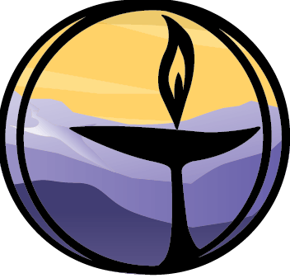
Pluralism (Soul Matters Edition)
Covenant Group Session Plan
Greenville Unitarian Universalist Fellowship, Greenville, South Carolina
Based on material from Soul Matters-Small Group: The Gift of Pluralism, May 2024
Compiled and adapted by Denise Frick and Jim Hennigan, April 2024

Welcome, Chalice Lighting: Here we are, together in this space. By our love and by our covenant, we make this a holy place. We light the chalice of Unitarian Universalism in honor of the light that lives in each of us, the light that shines among us, and the light we bring into the world.

Personal Check In: Briefly share something from your life since we last met and how you are feeling now.

Opening Words:
Pluralism - We celebrate that we are all sacred beings, diverse in culture, experience, and theology. We covenant to learn from one another in our free and responsible search for truth and meaning. We embrace our differences and commonalities with Love, curiosity, and respect. ~from Article II Purpose and Covenant Proposal, UUA

Questions to prompt and guide discussion:
- What were you taught in your family of origin about pluralism and welcoming difference? How does that still impact you today?
- If you could go back and change a moment of being excluded or excluding someone else, what would it be?
- When it comes to age, our society is not as pluralistic as it thinks. Have you been ignored or cast out because of your age? Was it more emotionally challenging to accept than you expected? Please share about this experience.
- Is it possible that the aspect that so annoys you about that other person echoes a similar part of yourself you deny? If so, share your thoughts on this.
- Our friends and family each carry/believe/tell a different story about who we are. Whose version of you most closely matches your authentic self? Whose version do you disagree with most strongly? Whose version challenges you to be your best self? Whose do you hope to someday become?
- Have you been part of a group that's been changed or transformed by the addition of new and "different" people to the group? How did your experience of this change reflect embracing plurality as a value? How might a change like this be experienced differently if the group is intentional about allowing plurality to be a catalyst for change to the group?

Readings – see below

Sharing - This is a time to speak without interruption and for deep listening. Deep listening means no interrupting, no fixing, no saving, no advising, and no setting each other straight. Please share one or more responses to the session questions or the readings.
(After each person has shared, this can be a good time to take a brief break)
Open Discussion - This is a time to respond to something another person said about the topic or to relate additional thoughts that may have occurred as others shared their thoughts on this topic. Continue to practice deep listening.

Closing reading:
Lives are lived in parallel and perpendicular, fathomed nonlinearly, figured not in the straight graphs of “biography” but in many-sided, many-splendored diagrams… There are infinitely many kinds of beautiful lives.
~Maria Popova, Bulgarian-born, American-based author

Announcements / Plans

Personal Check Out: As we leave today, how are you feeling now?

Extinguish the Chalice We extinguish this flame but not the light of truth, the warmth of community, or the fire of commitment. These we carry in our hearts until we are together again.

Readings
Inclusivity is not ‘how do we make you a part of what we are?’ but ‘how do we become more of what you are?’
~Rev. angel Kyodo Williams, Sensei- Zen Priest

Diversity is being invited to the party; inclusion is being asked to dance. ~Verna Myers, American diversity consultant, author

Diversity is not just about the differences you like. ~Eboo Patel, Author, Speaker, Educator, and Interfaith Leader

Pluralism isn’t easy. It’s a constant willingness to self-challenge and to look at where we might be wrong, or limited; even with regard to pluralism itself. It requires a capacity to detach ourselves from our agendas, our beliefs, our commitments, and to recognize that there may be other ways. And it also requires us to recognize that we can never wholly achieve that. ~Mick Cooper, British Professor of Counselling Psychology

Differences challenge assumptions. ~Anne Wilson Schaef, American clinical psychologist, and author

He drew a circle that shut me out-
Heretic, rebel, a thing to flout.
But love and I had the wit to win:
We drew a circle and took him in! ~Edwin Markham, American poet, 1852-1940

You have your way. I have my way. As for the right way, the correct way, and the only way, it does not exist.
~Friedrich Nietzsche, German philosopher, 1844-1900

If I had access to people who looked like me growing up, my life would have been so much easier. The suicide rates for trans and non-binary youth, especially trans and non-binary youth of color, are astronomical. And the reason they're so high is because when you tell us we don’t exist, at some point we begin to believe you. And media representation is actually a visual argument to the world, [saying], “We’re here. We’re queer. We’re trans. We’re people of color. We’re gender non-conforming. Our lives matter. We're going and navigating through things that are simultaneously extremely similar to you and extremely different for you, and you cannot erase us!” ~Alok Vaid-Menon, American writer, performance artist, and media personality

The first thing I am is a person… But people either relate to you as an Indian or as a woman. They relate to you as a category. ~Winona LaDuke, Anishinaabe author, and activist

Ask yourself, “What kinds of people do I talk about but never talk with?” Whoever is underrepresented in your life, will be overrepresented in your imagination!... This is the truth of our divided landscape.
~Mónica Guzman, journalist, and entrepreneur

People are just as wonderful as sunsets if I can let them be. In fact, perhaps the reason we can truly appreciate a sunset is that we cannot control it. When I look at a sunset as I did the other evening, I don’t find myself saying, ‘Soften the orange a little on the right hand corner, and put a bit more purple along the base, and use a little more pink in the cloud color.’ I don’t do that. I don’t try to control a sunset. I watch it with awe as it unfolds. I like myself best when I can appreciate my staff member, my son, my daughter, my grandchildren, in this same way.
~Carl Rogers, American psychologist, 1902-1987

Why be a star when you can make a constellation? ~Mariam Kaba, American activist, grassroots organizer, and educator

To be free, you must embrace the breadth of your own existence without apology… But to actually be free, you must know and you must fight for the entire Universes inside of everyone else.
~Julián Jamaica Soto, UU Minister, and activist

Once we reckon with the paradox of how the perceived other is both distinct, and a direct reflection of us, then we see ourselves in that mirror. We see everyone and everything as reflecting an aspect of ourself that we get to reclaim. Those we might have judged become guideposts for our own liberation. Our triggers become welcomed signs that we have rejected something inside us.
The idea that you are either with us or against us is a limiting lens that perpetuates humanity's suffering. The recognition that you are us, that everyone is us, allows our self-love to humanize others into belonging.
~Gareth Gwyn, You Are Us: How to Build Bridges in a Polarized World

The religious community is essential, for alone our vision is too narrow to see all that must be seen, and our strength too limited to do all that must be done. Together, our vision widens. ~Rev. Dr. Mark Morrison-Reed, UU Minister

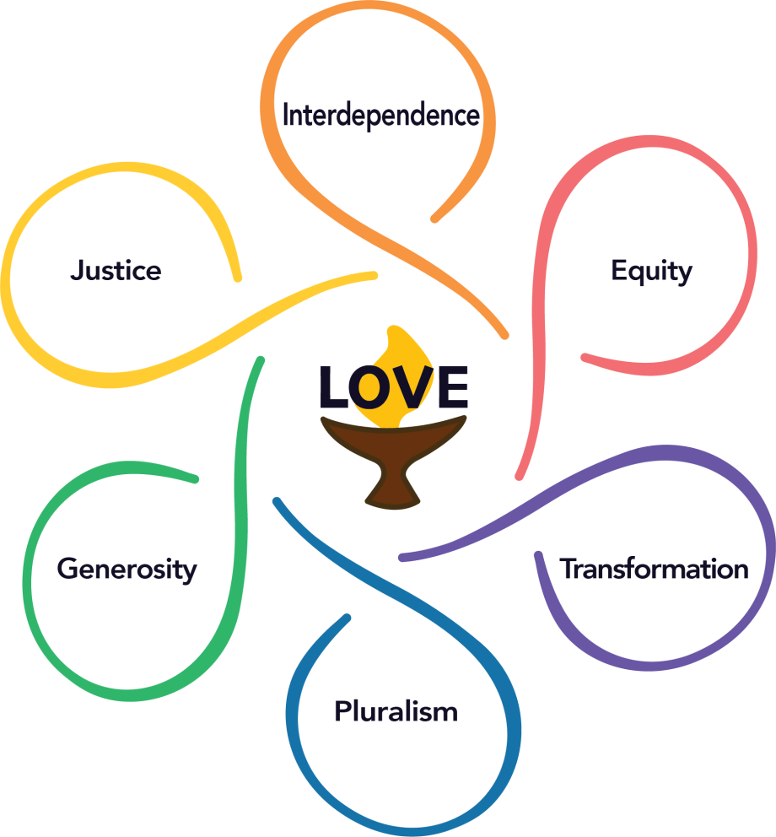
Because she wanted everyone to feel included
in her prayer, she said right at the beginning
several names for the Holy:
Spirit, she said, Holy One, Mystery, God…
Then, although she hadn’t imagined it this way,
others began to offer names:
Peace, said one.
One My Mother Knew, said another.
Ancestor, said a third.
Wind.
Rain.
Breath, said one near the back.
Refuge.
That Which Holds All…

And then, there wasn’t any need to say the things
she’d thought would be important to say,
and everyone sat hushed, until someone said
Amen.
~Nancy Shaffer, Instructions in Joy, UU Minister, Poet, 1950-2012

